***Input00***

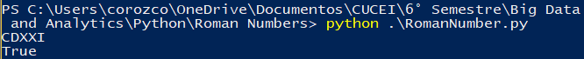

***Input01***

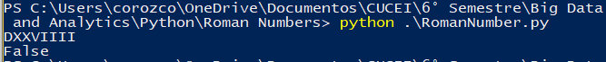

***Input02***

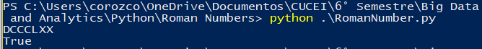

***Input03***



***Input04***

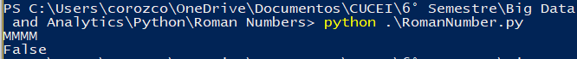

***Input05***

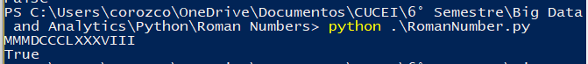

***Input06***

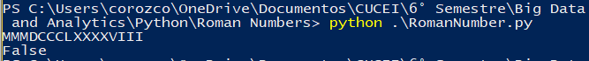

***Input07***



***Input08***

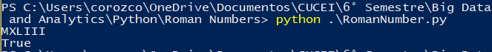

***Input09***

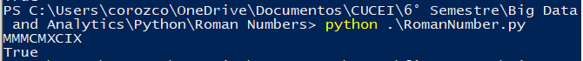

I Create more test cases because I have to change my Regular Expression with this. I found that if you have for example a CD or CM you cannot have later any C, and at First, I didn’t contemplate it

